A
Real-Time Research Project Report on

JUSTICE SCAM-AWARENESS&

PREVENTION SYSTEM

Submitted
In Partial Fulfilment of the Requirements for the Award of Degree BACHELOR OF TECHNOLOGY
IN

COMPUTER SCIENCE AND ENGINEERING

Submitted By

P.SHIVA KUMAR 247Z1A05M8



SCHOOL OF ENGINEERING

Department of Computer Science And Engineering

NALLA NARASIMHA REDDY
EDUCATION SOCIETY’S GROUP OF INSTITUTIONS
(Approved by AICTE, New Delhi, Affiliated to JNTU-Hyderabad) Chowdariguda (VIll) Korremula 'x' Roads, Via Narapally, Ghatkesar (Mandal) Medchal (Dist), Telangana-500088
2025-2026



SCHOOL OF ENGINEERING DEPARTMENT OF COMPUTER SCIENCE AND
ENGINEERING

CERTIFICATE

This is to certify that the real-time research project report titled “Justice Scam-Awareness & Prevention System” is being submitted by Peddakurva Shivakumar (247Z1A05M8) in Partial fulfilment for the award of Bachelor of Technology in Computer Science And Engineering is a record bonafide work carried out by them. The results embodied in this report have not been submitted to any other University for the award of any degree.

Internal Guide Head of the Department
(Dr. A. Prashanthi,Assoc.Prof,CSE) (Dr. K. Rameshwaraiah)

Submission Date :

DECLARATION

I, Peddakurva Shivakumar student of Bachelor of Technology in Computer Science and Engineering, Nalla Narasimha Reddy Education Society’s Group of Institutions, Hyderabad, Telangana, now declare that the work presented in this project work entitled “Justice Scam-Awareness&Prevention System”, is the outcome of my bonafide work and is correct to the best of our knowledge. This work has been undertaken taking care of engineering ethics. It contains no material previously published or written by another person nor material which has been accepted for the award of any other degree or diploma of the university or other institute of higher learning.

P. SHIVAKUMAR 247Z1A05M8

Date:

Signature

ACKNOWLEDGEMENT

I want to express our profound gratitude to our real-time research project coordinator, Dr.A.Prashanthi,Assoc.Prof,CSE Department of Computer Science and Engineering(CSE), NNRESGI, for her support and guidance in completing my project, and for giving me this opportunity to present the research project work.
I profoundly express thanks to Dr. K. Rameshwaraiah, Professor & Head, Department of Computer Science and Engineering, NNRESGI, for his cooperation and encouragement in completing the project successfully.
I wish to express our sincere thanks to Dr. G. Janardhana Raju, Dean School of Engineering, NNRESGI, for providing the facilities for the completion of the project.
I wish to express our sincere thanks to Dr. C. V. Krishna Reddy, Director, NNRESGI, for providing the facilities for the completion of the project.
Finally, I would like to thank the project coordinator, all the faculty members and supporting staff, Department of Computer Science and Engineering, NNRESGI, for extending their help in all circumstances.

By
P.SHIVAKUMAR
(247Z1A05M8)

ABSTRACT
The Justice Scam Awareness and Prevention System is designed to protect users from increasing digital fraud and scam activities. With the rapid growth of online transactions and communication, people are becoming more vulnerable to scams such as phishing, fake job offers, OTP fraud, and UPI-based frauds. This system aims to create awareness among users by providing detailed information about various types of scams and their prevention methods.
The proposed system includes features such as scam detection, alert notifications, and a reporting mechanism that allows users to report suspicious activities. It also enables users to verify unknown links, messages, or calls to identify potential threats. An admin module is included to manage reported cases and update users about new and trending scams.
By combining awareness, detection, and reporting functionalities, the system helps users make informed decisions and avoid financial losses. This project contributes to enhancing cybersecurity awareness and promotes safe digital practices among the public.

CONTENTS
Page no.
ABSTRACT i

List of Figures iv
List of Abbreviations v
- INTRODUCTION 1
  - Problem Definition 1
  - Objective of Project 1
  - Limitation of project 2
- SYSTEM ANALYSIS 3
  - Existing System 3
  - Proposed System 3
  - Software Requirements 3
    - Functional and Non-Functional Requirements 4
  - Hardware Requirements 5
  - Content Diagram of the Project 5
  - Architecture of the Project 6
- IMPLEMENTATION 7
  - Method of Implementation (Technology Description) 7
  - Algorithmic Approach 8
  - Explanation of Key Functions 9
  - Sample Code 11
- OUTPUT SCREENSHOTS 13
- CONCLUSION AND FUTURE ENHANCEMENT 16
  - Project Conclusion 16
  - Future Enhancement 16
- REFERENCES 17
  - Web References 17

List of Figures

S.no Figure no Name of the Figure Page no.

- 2.5 Content Diagram of Project 5
- 2.6 Architecture of the Project 6

List of Abbreviations

S.no Abbreviation Definition

  - RTC Real Time Communication
  - API Application Programming Interface
  - UI User Interface
  - UX User Experience
  - DB Database

INTRODUCTION

In today’s digital era, the use of the internet, online banking, and mobile applications has increased rapidly. Along with these advancements, the number of cybercrimes and scam activities has also grown significantly. Many people fall victim to scams such as phishing attacks, fake job offers, lottery scams, OTP fraud, and UPI-related fraud due to lack of awareness and proper knowledge.

The Justice Scam Awareness and Prevention System is developed to address this issue by educating users about various types of scams and providing tools to detect and prevent them. This system acts as a platform where users can learn about common fraud techniques, identify suspicious activities, and report scam incidents.

The system not only focuses on spreading awareness but also helps in early detection of potential threats through alert mechanisms and verification tools. It provides a user-friendly interface for individuals to check suspicious messages, links, or calls, thereby reducing the risk of financial and personal data loss.

Overall, this project aims to enhance cybersecurity awareness among users and promote safe digital practices, making online interactions more secure and reliable.

If you want, I can next give you:

Problem Statement

Literature Survey

System Architecture

1.1Problem Definition
In the current digital age, the use of online platforms for communication, banking, shopping, and job searching has increased significantly. However, this rapid digital growth has also led to a rise in cybercrimes and scam activities such as phishing, OTP fraud, UPI fraud, and fake job offers. Many users, especially those with limited technical knowledge, are unable to identify these scams and often become victims of financial loss and data theft.
Existing systems mainly focus on reporting scams rather than preventing them. There is a lack of a unified platform that provides awareness, detection, and prevention of scams in an easy and accessible manner. Users often do not have proper tools to verify suspicious messages, links, or calls before taking action.
1.2 Objectives of the Project
- To Create Awareness To educate users about different types of scams such as phishing, OTP fraud, UPI fraud, and fake job scams.
- To Prevent Scam Activities To provide preventive measures and guidance to help users avoid becoming victims of fraud.
- To Detect Suspicious Content To enable users to check and identify suspicious links, messages, or calls.
- To Provide Reporting Facility To allow users to report scam incidents easily through the system.

Limitation of Project

Limited Detection Accuracy The system may not always correctly identify new or advanced scam techniques, especially zero-day frauds.

Dependenceon User Input The effectiveness of the system depends on the information provided by users, which may sometimes be incomplete or incorrect.

Lack of Real-TimeData Integration Without integration with official cybercrime databases, the system may not have access to the latest scam information.

Internet Dependency The system requires an active internet connection, limiting its usage in offline environments.

Basic Security Measures If not implemented with strong security protocols, the system itself could be vulnerable to attacks.

2. SYSTEM ANALYSIS

Existing system

Currently, scam awareness and prevention are handled through various independent platforms such as government websites, cybercrime portals, news channels, and social media. Users can report fraud cases through official cybercrime websites, but these platforms mainly focus on complaint registration rather than providing complete awareness and prevention tools.

Most existing systems lack a unified solution that combines awareness, detection, and reporting in one place. Users often have to search different sources to understand scams, verify suspicious content, or take action. Additionally, many people are unaware of official platforms or do not know how to use them effectively.

Existing systems also do not provide

2.1.1Disadvantages

Not100% Accurate The system may fail to detect new or advanced scam techniques.

Dependenceon Interne tRequires a stable internet connection to function properly.

User Awareness Required Users must actively use the system; otherwise, it provides no benefit.

Limited Real-Time Updates Without continuous updates, the system may not reflect thelatest scam trends.

Data Privacy ConcernsUser information and reported data must be handled securely to avoid misuse.

Proposed System
The Justice Scam Awareness and Prevention System is designed as an integrated platform that combines awareness, detection, and reporting of scams in a single system. The proposed system aims to overcome the limitations of existing systems by providing a user-friendly interface and multiple features to help users identify and prevent fraud.
The system provides a dedicated awareness section where users can learn about different types of scams such as phishing, OTP fraud, UPI fraud, and fake job scams along with preventive measures. It includes a scam detection module that allows users to check suspicious links, messages, or calls to determine their authenticity.
Additionally, the system offers a reporting feature where users can easily report scam incidents, which are then reviewed by the admin. An alert mechanism is implemented to notify users about new and trending scams, helping them stay updated in real time.
The admin module manages user reports, updates scam information, and monitors system activities. The proposed system ensures better accessibility, improved awareness, and early detection of scams, thereby reducing the chances of financial and data loss.
2.2.1Advantages
1. Increases Awareness
Educates users about various types of scams and fraud techniques.
2. Prevents Financial Loss
Helps users avoid scams, reducing the risk of money loss.
3.Early Scam Detection
Identifies suspicious links, messages, and calls before harm occurs.
4.Easy Reporting System
users to report scams quickly and efficiently.
5. User-Friendly Interface
Simple and easy to use for all types of users.

Software Requirements

The development and implementation of the Justice Scam Awareness and Prevention System require the following software components:
  - Operating System
  - Windows / Linux / macOS
  - Frontend Technologies
  - HTML
  - CSS
  - JavaScript
  - Backend Technologies
  - Python / Java / Node.js
  - Database
  - MySQL / MongoDB
  - Development Tools
  - Visual Studio Code / Eclipse / IntelliJ IDEA

Web Browser

Google Chrome / Mozilla Firefox

Additional Software (Optional)

XAMPP / WAMP (for local server setup)

Git (for version control)

2.3.1 Functional and Non-Functional Requirements

Functional Requirements

Functional requirements describe what the system should do:

User Registration and Login The system should allow users to create accounts and securely log in.

Scam Awareness Module The system should provide information about different types of scams and prevention methods.

Scam Detection Users should be able to check suspicious links, messages, or calls.

Report Scam Feature Users should be able to report scam incidents easily.

Alert/Notification System The system should notify users about new or trending scams.

Admin Module Admin should manage user reports, update scam data, and monitoractivities.

Search Functionality Users should be able to search for specific scam-related information.

Non-Functional Requirements

Non-functional requirements describe how the system should perform:

Performance
The system should respond quickly to user requests.

Security
User data should be protected using authentication and encryption techniques.

Usability
The system should have a simple and user-friendly interface.

Reliability
The system should work consistently without failures.

Scalability
The system should handle an increasing number of users and data.

Availability
The system should be accessible at all times with minimal downtime.

Maintainability
The system should be easy to update and fix bugs.

2.4 Hardware Requirements
The Justice Scam Awareness and Prevention System requires a standard computer system with basic hardware configuration for smooth development and operation. A system with an Intel i3 processor or higher (or equivalent) is sufficient to handle the application efficiently. It requires a minimum of 4 GB RAM, although 8 GB is recommended for better performance and multitasking. The system should have at least 500 GB of hard disk storage to store application files, databases, and related data. A 32-bit or 64-bit system can be used depending on software compatibility. Basic input devices such as a keyboard and mouse, along with an output device like a monitor, are necessary for user interaction. Additionally, a stable internet connection is essential for accessing online features, updating scam information, and enabling real-time alerts.
Processor
- Intel i3 or above (or equivalent)
RAM
Minimum 4 GB (8 GB recommended for better performance)
Hard Disk
- Minimum 500 GB storage
System Type
- 32-bit or 64-bit computer
Input Devices
Keyboard and Mouse

2.5 Content Diagram
The content diagram of the Justice Scam Awareness and Prevention System represents the flow of information and interaction between different components of the system. It illustrates how users interact with the system by accessing features such as scam awareness, scam detection, and reporting modules. The diagram shows that the user provides input in the form of suspicious messages, links, or complaints, which are processed by the system. The system then analyzes the input, retrieves relevant data from the database, and provides appropriate outputs such as scam alerts, verification results, or confirmation of reported cases. It also includes the admin module, which manages user reports, updates scam-related information, and monitors overall system activities. Thus, the content diagram helps in understanding how data flows within the system and how different modules are interconnected to ensure effective scam awareness and prevention.

+-------------------+
| User |
+-------------------+
|
v
+----------------------------------+
| Justice Scam Awareness System |
+----------------------------------+
| | | |
v v v v
Awareness Detection Reporting Alerts
Module Module Module Module
\ | | /
\ | | /
v v v v
+-------------------+
| Database |
+-------------------+
|
v
+-------------------+
| Admin |
+-------------------+



Figure.2.5: Content Diagram

IMPLEMENTATION

Method of Implementation

The Justice Scam Awareness and Prevention System is implemented using a structured development approach that includes design, development, and testing phases. Initially, the system requirements are analyzed, and a suitable architecture is designed to integrate modules such as user interface, scam awareness, detection, reporting, and admin management. The frontend is developed using technologies like HTML, CSS, and JavaScript to provide a user-friendly interface, while the backend is implemented using a programming language such as Python, Java, or Node.js to handle logic and data processing. A database like MySQL or MongoDB is used to store user information, scam data, and reports. The system processes user inputs such as suspicious links or messages, analyzes them, and generates appropriate outputs like alerts or verification results. The admin module is implemented to manage reports and update scam-related information. Finally, the system is tested for functionality, performance, and security to ensure reliable and efficient operation.

Technologies Used

The Justice Scam Awareness and Prevention System is developed using a combination of frontend, backend, and database technologies to ensure efficient performance and user-friendly interaction. The frontend of the system is built using HTML, CSS, and JavaScript, which provide an interactive and responsive user interface. The backend is developed using programming languages such as Python, Java, or Node.js, which handle the core logic, data processing, and communication between the user interface and the database.

For data storage and management, databases like MySQL or MongoDB are used to store user details, scam information, and reported cases. Development tools such as Visual Studio Code, Eclipse, or IntelliJ IDEA are used for coding and debugging purposes. Additionally, web browsers like Google Chrome or Mozilla Firefox are used for testing and accessing the system. Optional tools like XAMPP or WAMP can be used for local server setup, and Git can be used for version control and project management.

HTML, CSS, Java Script

HTML, CSS, and JavaScript are used as the core frontend technologies in the development of the Justice Scam Awareness and Prevention System. HTML (HyperText Markup Language) is used to design the structure of web pages, including forms, buttons, and content sections. CSS (Cascading Style Sheets) is used to enhance the visual appearance of the system by applying styles such as colors, layouts, and responsiveness. JavaScript is used to add interactivity and dynamic behavior, such as form validation, user input handling, alert messages, and communication with the backend. Together, these technologies create a user-friendly and interactive interface for the system.
.

Node.js / Python (Backend Development)

- Node.js
  - Used to build fast and scalable server-side applications
  - Handles client requests and server responses efficiently
  - Supports asynchronous programming for better performance
  - Useful for real-time features like alerts and notifications
- Python
  - Simple and easy-to-learn programming language
  - Used for backend logic and data processing
  - Supports frameworks like Flask and Django for web development
  - Can be used for implementing scam detection using AI/ML

WebSockets (Real-Time Communication)
Real-Time Communication
Enables instant data exchange between client and server
Persistent Connection
Maintains a continuous connection instead of repeated requests
Faster Data Transfer
Reduces delay compared to traditional HTTP requests
Used for Alerts and Notifications
Helps in sending real-time scam alerts to users
Efficient Performance
Reduces server load by avoiding repeated connections
Bidirectional Communication Allows both client and server to send data at any time

Database (MongoDB / MySQL)

The database plays a crucial role in the Justice Scam Awareness and Prevention System by storing and managing all the system data efficiently. Databases such as MongoDB and MySQL are used to store user information, scam details, reported cases, and alert data. MySQL is a relational database that organizes data in tables with structured relationships, making it suitable for applications requiring consistency and complex queries. On the other hand, MongoDB is a NoSQL database that stores data in a flexible, document-based format, which is useful for handling unstructured or rapidly changing data. The database enables quick retrieval and updating of information, ensuring smooth functioning of features like scam detection, reporting, and real-time alerts.

3.2 Algorithmic Approach
The algorithmic approach of the Justice Scam Awareness and Prevention System focuses on processing user inputs and identifying potential scam activities through a series of logical steps. Initially, the system accepts input from the user in the form of messages, links, or complaint data. This input is then preprocessed to remove unnecessary or irrelevant information. The system compares the processed input with existing scam patterns and data stored in the database using predefined rules or pattern-matching techniques. If the input matches known scam characteristics, the system flags it as suspicious and generates an alert for the user. Otherwise, it is marked as safe or inconclusive. Additionally, the system stores reported cases and continuously updates its database to improve detection accuracy. This step-by-step approach ensures efficient detection, quick response, and continuous improvement in identifying scam activities.

STEPS

• Start Begin the process.
• User Input Accept input from the user (message, link, or complaint).
• Data Preprocessing Clean and format the input data by removing unnecessary information.
• PatternMatchingCompare the input with stored scam patterns and database records.
• AnalysisAnalyze the input using predefined rules or detection logic.
• Decision Making
If matched → Mark as Scam/Suspicious
Else → Mark as Safe/Unknow

3.3Explanation of Key Functions
The Justice Scam Awareness and Prevention System consists of several key functions that work together to ensure effective scam detection and user protection. The user authentication function allows users to register and log in securely, ensuring that only authorized users can access the system. The scam awareness function provides detailed information about different types of scams and preventive measures, helping users stay informed. The scam detection function analyzes user inputs such as suspicious links or messages and compares them with stored data to identify potential threats.
The reporting function enables users to report scam incidents easily, which are then stored in the database for further analysis. The alert and notification function sends real-time updates to users about new or trending scams. Additionally, the admin management function allows administrators to monitor user activities, manage reports, and update scam-related information in the system. Together, these functions ensure smooth operation, improved awareness, and effective prevention of scam activities.

Message Handling

Message handling is a key function of the Justice Scam Awareness and Prevention System that deals with processing user-submitted messages. The system accepts messages such as SMS, emails, or chat content that may be suspected of being fraudulent. These messages are first preprocessed by removing unnecessary characters and formatting the text for analysis. The system then examines the content using pattern-matching techniques and compares it with known scam indicators such as suspicious links, keywords (e.g., “OTP”, “urgent”, “winner”), or unusual requests. Based on this analysis, the system classifies the message as safe, suspicious, or scam and provides appropriate feedback to the user. This function helps users quickly identify potentially harmful messages and avoid falling victim to scams.

Real-Time Communication
Real-time communication is an important function of the Justice Scam Awareness and Prevention System that enables instant interaction between the user and the system. It allows the system to send immediate alerts and notifications to users about suspicious activities or newly identified scams. This is typically implemented using technologies like WebSockets, which maintain a continuous connection between the client and server. As a result, users receive updates without needing to refresh the page. Real-time communication ensures quick response, timely warnings, and improved user safety by delivering critical information as soon as it is available.

Database Management
Database management is a crucial function of the Justice Scam Awareness and Prevention System that handles the storage, retrieval, and organization of all system data. It manages user information, scam records, reported cases, and alert details in a structured and efficient manner. The system uses databases like MySQL or MongoDB to store data securely and ensure quick access when needed. It supports operations such as adding new records, updating scam information, and retrieving data for analysis and detection. Proper database management ensures data consistency, reliability, and smooth functioning of features like scam detection, reporting, and real-time alerts.

Notification System

The notification system is an essential function of the Justice Scam Awareness and Prevention System that keeps users informed about important updates and potential threats. It sends alerts and warnings to users regarding newly detected scams, suspicious activities, or updates in reported cases. Notifications can be delivered in real time through pop-up messages, emails, or in-app alerts. This system ensures that users receive timely information without needing to manually check for updates. By providing instant alerts, the notification system helps users take quick action and avoid falling victim to scams.

Sample Code

Public.html

<!DOCTYPE html>
<html lang="en">
<head>
<meta charset="UTF-8">
<title>Scam Awareness System</title>
<style>
body {
font-family: Arial;
background-color: #f4f4f4;
text-align: center;
}
.container {
margin-top: 50px;
}
input, button {
padding: 10px;
margin: 10px;
width: 250px;
}
button {
background-color: #007BFF;
color: white;
border: none;
}
</style>
</head>
<body>
<div class="container">
<h1>Justice Scam Awareness System</h1>
<h3>Check Suspicious Message</h3>
<input type="text" id="message" placeholder="Enter message or link">
<br>
<button onclick="checkScam()">Check</button>
<h3 id="result"></h3>
</div>
<script>
function checkScam() {
let msg = document.getElementById("message").value.toLowerCase();
if(msg.includes("otp") || msg.includes("winner") || msg.includes("urgent")) {
document.getElementById("result").innerHTML = "Suspicious Message!";
} else {
document.getElementById("result").innerHTML = " Seems Safe";
}
}
</script>
</body>
</html>

4.OUTPUT SCREENSHOTS

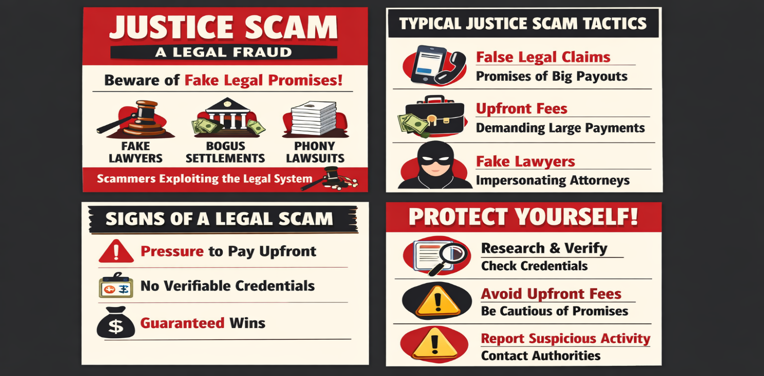Figure
      - Message Sent:

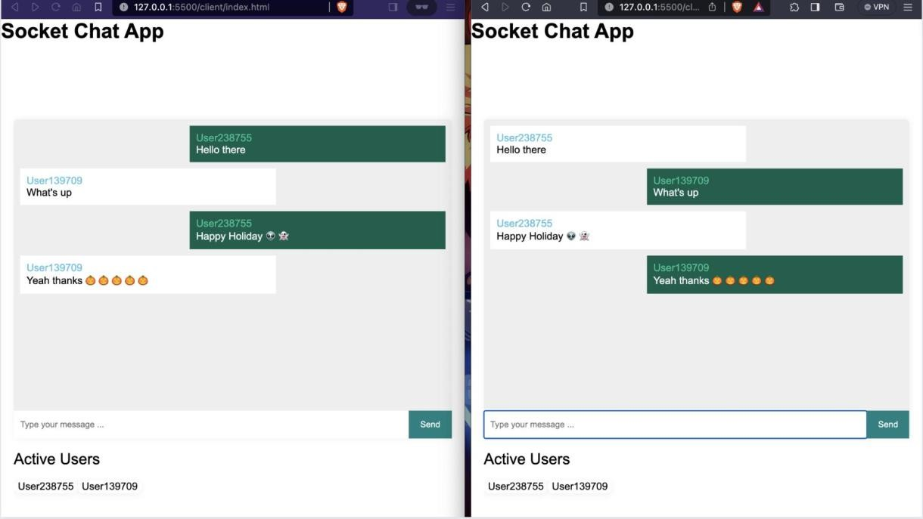

Figure 4.3: Message Sent

Real-Time Messaging:


Figure 4.4: Real-Time Messaging

Multiple Messages Display:
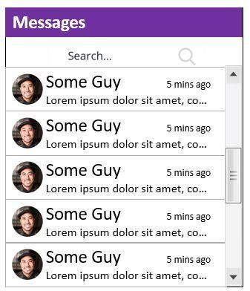
Figure 4.5: Multiple Messages Display./

      - Algorithm Applied: The chat window becomes scrollable as messages increase.
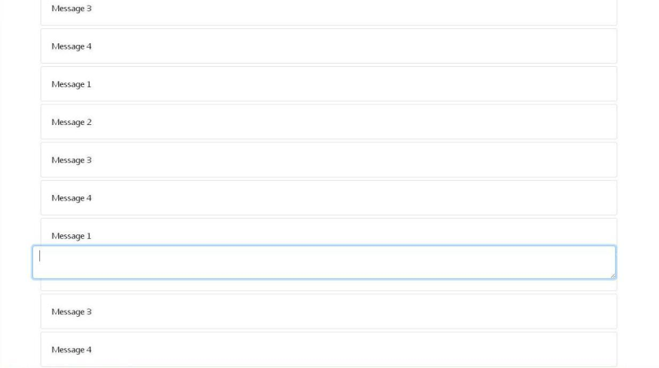

Figure 4.6: Algorithm Applied

5.CONCLUSION AND FUTURE ENHANCEMENT

Project Conclusion
The Justice Scam Awareness and Prevention System is developed to help users identify and prevent online scams effectively. The system provides a simple and user-friendly interface where users can check suspicious messages or links. By analyzing input using predefined keywords and logic, the system quickly classifies messages as safe or suspicious. It also improves user awareness by providing alerts and enabling reporting of scam incidents. Overall, the project successfully demonstrates how technology can be used to enhance security, reduce fraud risks, and protect users from cyber threats.
.

Future Enhancement

The Justice Scam Awareness and Prevention System can be further improved by incorporating advanced technologies and features. In the future, the system can be enhanced by implementing artificial intelligence and machine learning algorithms to provide more accurate and intelligent scam detection. Real-time data updates from online sources can be integrated to keep the system up to date with the latest scam trends. A mobile application can also be developed to make the system more accessible to users anytime and anywhere. Additionally, support for multiple languages can be added to reach a wider audience. Advanced link and phishing detection techniques can be included to identify harmful websites more effectively. Integration with official cybercrime portals can enable direct reporting of scams to authorities. These enhancements will make the system more efficient, reliable, and user-friendly.

6. REFERENCES

Web References
https://www.w3schools.com
https://www.geeksforgeeks.org
https://developer.mozilla.org
https://nodejs.org
https://www.python.org
https://www.mongodb.com

